|  |
| --- |
| REGISTERS  IN C.A  Computer architecture |
| Amirshayan Jalili Phone: 09101943345  Email shayan138190@gmail.com |



**Table of contents**

* Introduction Registers
* Type of Registers
* Memory Address Register (MAR)
* Program Counter (PC)
* Accumulator Register (AC)
* Memory Data Register (MDR)
* Index Register
* Memory Buffer Register (MBR)
* Data Register

**Introduction Registers**

Registers or memory registers of a computer processor are used to store and transfer data and instructions at a very high speed. As you know, the computer CPU is definitely one of the most important and complex components of a computer, and it is not a single-purpose and one-dimensional piece of hardware, and it is responsible for many tasks. Therefore, the register in the processor has different types, each of which in turn is very important and inevitable in handling and processing instructions for the CPU .

As you probably guessed, the register memory of the processor is one of the fastest memories of a computer ( even faster than the L1 cache memory of the processor ) , because the CPU stores the instructions in the register memory to perform its processes on the instructions and then on They do the processing . The registers of the processor are generally responsible for 3 tasks, namely Decode , Fetch and Execute, in the matter of processing commands, each of which will be explained below.

. 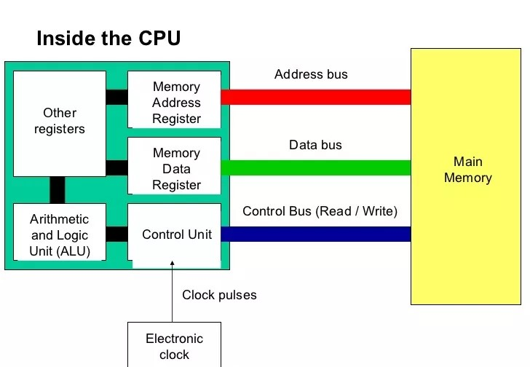

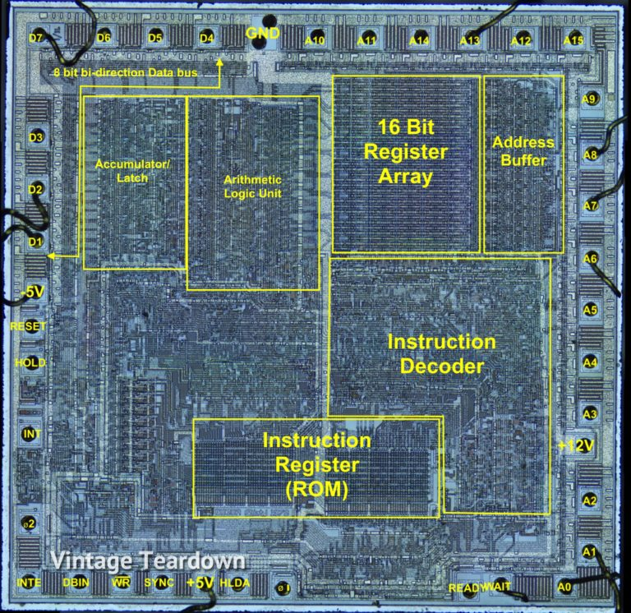

s **Type of Registers**

**Fetch or retrieve data :** Fetch operation consists of getting the instructions given by the user to the computer, as well as retrieving or fetching the instructions by registers from the RAM memory of the system in order to process the instructions .

Decode or decoding of instructions : The operation of decoding instructions is for the purpose of translating instructions into commands so that they can be executed by the ALU unit, the unit that supervises the operation of decoding instructions, the [CU unit](https://hardware.tosinso.com/tips/36248/%D9%88%D8%B8%DB%8C%D9%81%D9%87-control-unit-%DB%8C%D8%A7-%D9%88%D8%A7%D8%AD%D8%AF-%DA%A9%D9%86%D8%AA%D8%B1%D9%84-%D8%AF%D8%B1-cpu-%DA%86%DB%8C%D8%B3%D8%AA-%D8%9F) Or it is the control unit in the CPU .

Execute commands : As we said , the commands are executed by the ALU unit of the processor. After the execution of the commands by the ALU logic unit , the result is stored in the RAM memory of the system so that we can use the result of our commands .

, h What is the ALU unit

The calculation and logic unit in processors is a separate and sensitive part that is located in all old and new processors. This unit, which is used to calculate logic and account operations, is one of the most sensitive and important parts of processors. It doesn't matter if the processor is used as a computer CPU or a simple microchip .

ALU unit is known as a basic and important unit in processors. Even the simplest processors and microchips have this unit and perform the simplest computing parts in this unit. One of the most important tasks in calculation and logic is calculating time and maintaining it

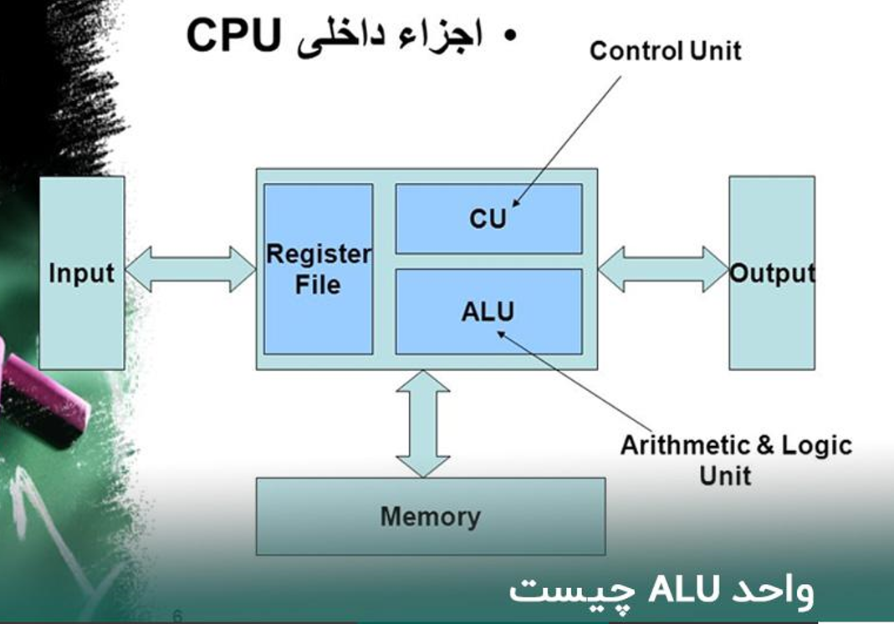

CU

The Control Unit manages all processor control signals, the CU unit The processor is actually the brain of the computer It is known because this unit manages and responds to orders and ensures the correct execution of issued instructions.

Control the execution of sequential instructions

Interpretation of instructions

Directing data flow between different components of computers

Setting and controlling processor timing

Sending and receiving control signals from other computer hardware

tasks such as fetching data, decoding data and executive management of instructions and finally storing the results .

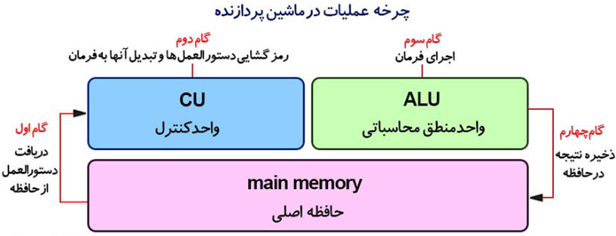

* **Memory Address Register (MAR)**

this register holds the memory addresses of data and instructions. This register is used to access data and instructions from RAM memory during the execution of instructions. Suppose the CPU wants to store some data in the RAM memory or on the contrary, it wants to call data from the RAM memory . MAR stores temporarily. Because if this was not the case, the CPU would not know where the instructions should be stored in the RAM memory. So if we think about this matter logically, the existence of a registry called MAR is mandatory .

* **Program Counter (PC)**

Program Counter register or **PC** for short is a register which is also called Instruction Pointer or IP . This register is sometimes called Instruction Address Register . This register stores the path of the memory address of the instruction that should be processed after the current instruction is finished. In other words, this register holds the memory address of the next instruction until the processing of the current instruction is completed.

* **Accumulator Register (AC)**

This register is used to store the results of the commands performed by the ALU unit of the system processor. When the CPU processes the instructions and is finished, the result of the instructions is temporarily stored in the AC register. to the Accumulator Register in **AX** technical terms They also say

**Memory Data Register (MDR)**

This register is one of the most important CPU registers, MDR register , [CU](https://hardware.tosinso.com/tips/36248/%D9%88%D8%B8%DB%8C%D9%81%D9%87-control-unit-%DB%8C%D8%A7-%D9%88%D8%A7%D8%AD%D8%AF-%DA%A9%D9%86%D8%AA%D8%B1%D9%84-%D8%AF%D8%B1-cpu-%DA%86%DB%8C%D8%B3%D8%AA-%D8%9F) unit register It is from the processor and contains information that must be stored in the system's RAM memory or other memories. Also, this register can contain data obtained by Fetch operation or retrieving data from a storage device. The MDR register is like [a buffer](https://hardware.tosinso.com/tips/36207/%D9%85%D9%86%D8%B8%D9%88%D8%B1-%D8%A7%D8%B2-buffer-%DB%8C%D8%A7-%D8%AD%D8%A7%D9%81%D8%B8%D9%87-%D8%A8%D8%A7%D9%81%D8%B1-%D8%AF%D8%B1-%D8%AF%D8%B3%D8%AA%DA%AF%D8%A7%D9%87-%D9%87%D8%A7-%DA%86%DB%8C%D8%B3%D8%AA-%D8%9F) It works and contains a copy of the information transferred from the RAM memory during the Fetch operation to this register to be processed by the CPU .

Note that the MDR contains information that has not yet been decoded by the processor's decoders . The MDR register contains information such as memory addresses that have been written to or read from RAM . For example, to fetch data from cell 123 (in binary), we load the value 123 (in binary) in the MAR register and perform the Fetch operation .

When the fetch operation is finished, a copy of the data in cell 123 should be written to the MDR register. Or as another example, to store the value 98 (in binary) in cell 4 in the memory, we must load the address of the data stored in cell 4 of the RAM memory in the MAR register and the data of this cell in the MDR register , and then the storage operation. Let's do the construction. When the Fetch operation is completed, the contents of cell 4 of the RAM memory will be filled with the value 98. The MDR register is a bi-directional register, which means that data is fetched from the memory and stored in the MDR register , which is actually written in one direction in this register. When an instruction is written, the data must be written in the MDR register and then stored in the RAM memory

* **Index Register**

This register in the processor keeps numbers or values that can be added or subtracted from part of the address of an instruction to become an effective and efficient address. Index Register is often called Base Register . Index Register in the computer processor is a register that is used to change operand addresses during the execution of a program. to the Index Register in the technical correction **of BX** They also say

* **Memory Buffer Register (MBR)**

This register stores the contents of data or instructions that are read from memory or written on it. In other words, this register is used to store data or instructions that are called from memory or loaded on it. The MBR register is the same as the MDR register and they have no difference .

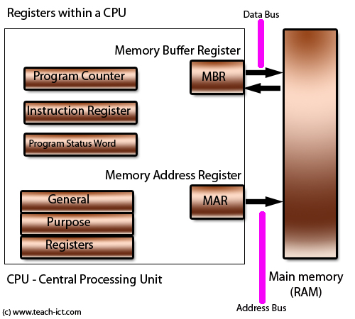

* **Data Register**

This register is used for temporary storage of data that is read or written from storage devices. to Data Register in **DX** technical terms They also say

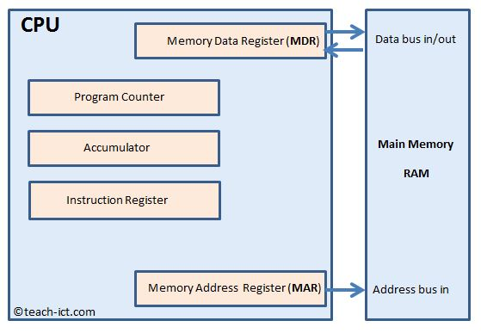

Below is a list of the most common registers used in a basic computer : _ _ _ _ _ _ _ _ _ _ _

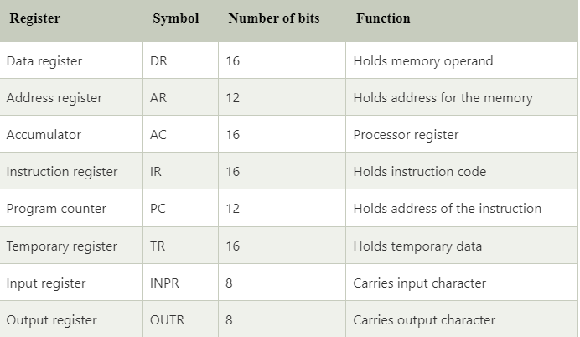

* Registers are part of the computer processor that are used to store and transfer data and instructions at a very high speed .
* Registers are one of the fastest memories of a computer, because the processor stores instructions in registers to perform its processing on instructions and then performs processing on them .
* Registers are generally responsible for 3 tasks, namely Decode , Fetch and Execute , in order to process commands :
  + Decode: instructions are translated into commands to be executed by the ALU unit .
  + Fetch: instructions are fetched from system RAM memory into registers .
  + Execute: Instructions are executed by the ALU unit of the processor .
* There are different types of constants, including :
  + Memory Address Register (MAR): Holds the memory addresses of data and instructions .
  + Program Counter (PC) Register : Holds the address of the current instruction .
  + Accumulator (AC): holds the result of the instructions performed by the ALU unit of the processor .
  + Memory Data Register (MDR): Holds data that is read from or written to memory .
  + Index register: It holds numbers or values that can be added or subtracted from part of the address of an instruction to become an effective and efficient address .
  + Memory Buffer Register (MBR): Stores the contents of data or instructions that are read from or written to the memory .
  + Data register: holds data that is read or written from storage devices .

Amirshayan Jalili

[Shayan138190@gmail.com](mailto:Shayan138190@gmail.com)

<https://github.com/Amirshayan2002>